Welcome to the Hoya Safety Website

Overview

The Manager’s role is to allocate a Purchase Order for prescription safety glasses. This will mean finding an existing Employee (who has already be registered on this site) OR adding a new employee to the site.

An optometrist must be allocated to the employee along with the Company’s Purchase Order.

Please note that the Company’s policies are already loaded to the site.

If the Company does not require a quotation for each employee the order goes directly to the optician. Once the employee has had their eye examination and safety glasses chosen they will be manufactured and returned to the optician.

The optician will advise the Manager when they are ready for the employee to collect.

If the Company requires a quote for each order, the issuing Manager will receive an email with the final order for review and approval. Once that is returned (emailed) to the optician the safety glasses will be order as above.

3 Easy Steps to Create a Purchase Order;

Step 1 Find an existing Employee who has had prescription safety glasses (through this site) before OR Add a new Employee

Step 2 Find and allocate a suitable Optometrist for the Employee and insert your Purchase Order number

Step 3 Send the order to the Optometrist

Scroll down to read the screen shots and instructions ....

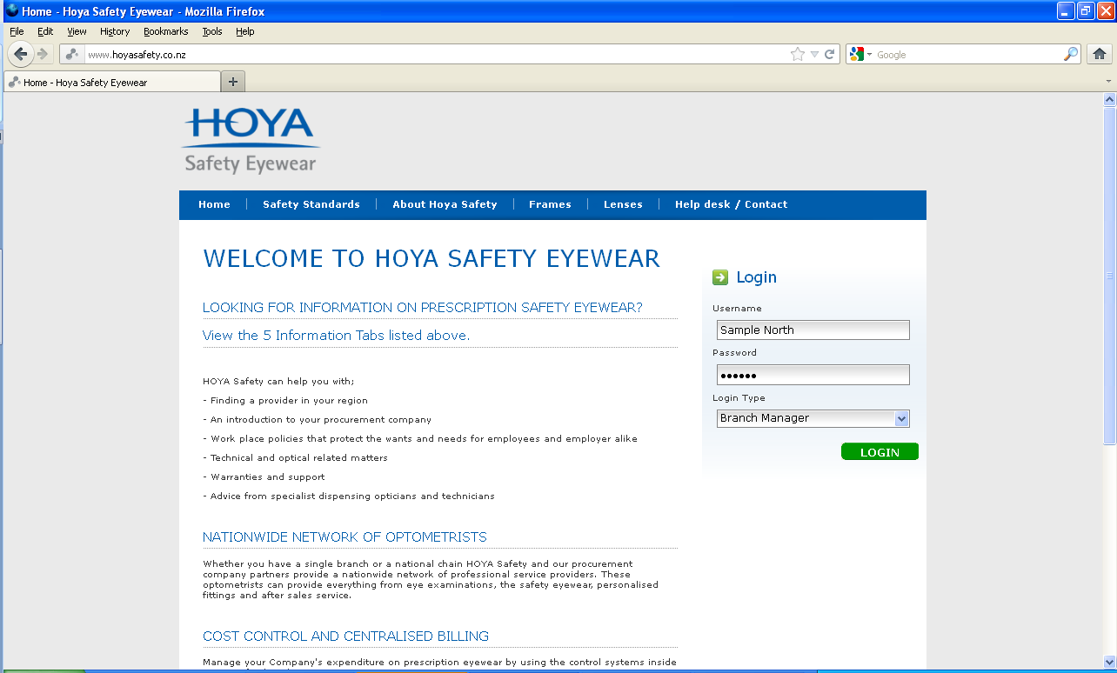
User Guide for a Branch Manager to Order Prescription Safety Glasses
Use these tabs to learn about prescription safety eyewear.
Enter your User name and Password for your Company Branch.

Select Branch Manager in the login type, click LOGIN

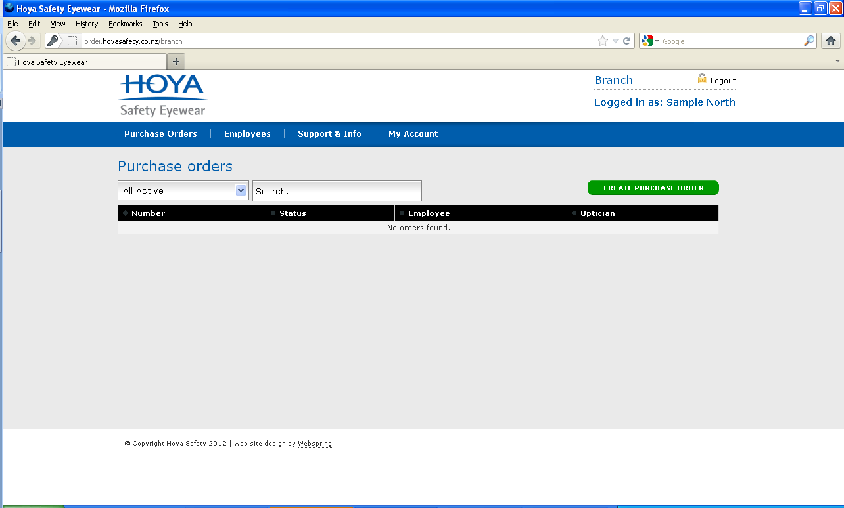
Click here if you have an existing employee registered and you want to select them and create a purchase order for them.
Click EMPLOYEES to either select an existing employee OR add an employee.
This indicates your login in status

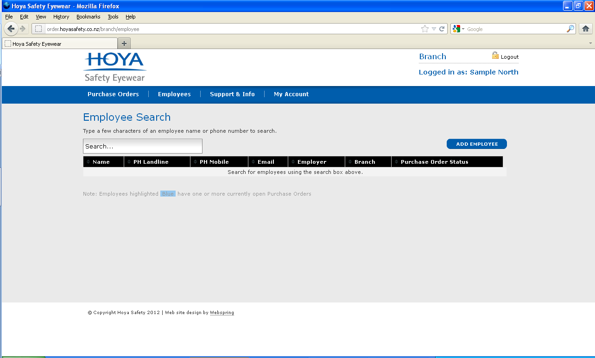
Click here to add an employee
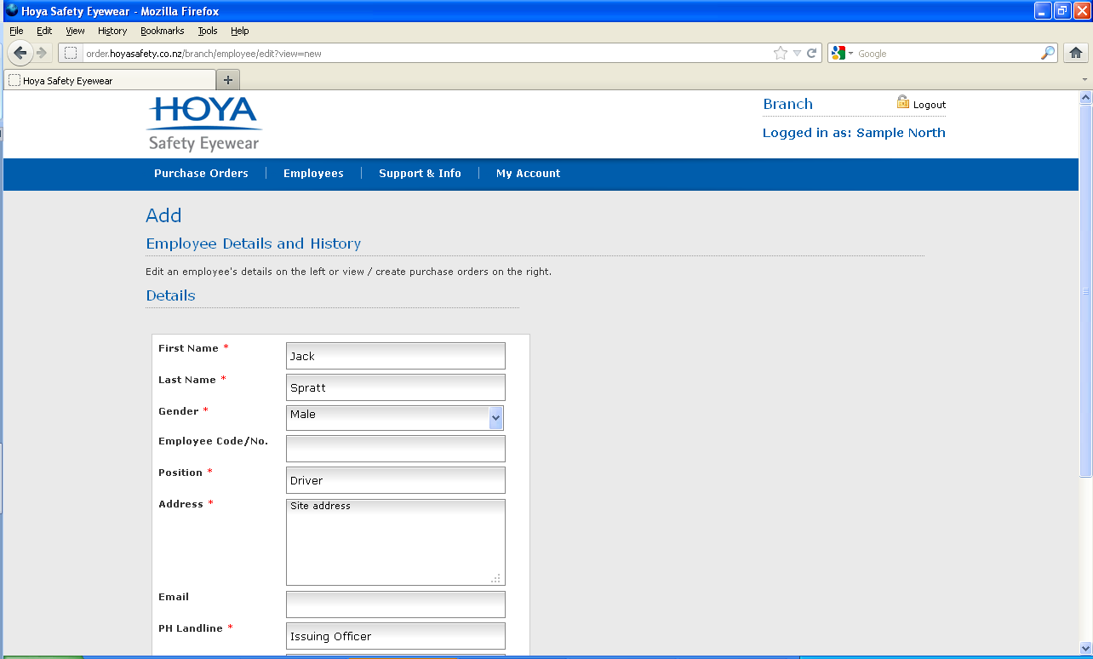
Complete this form. An * means this field must be filled in.
... lower part of screen shot.

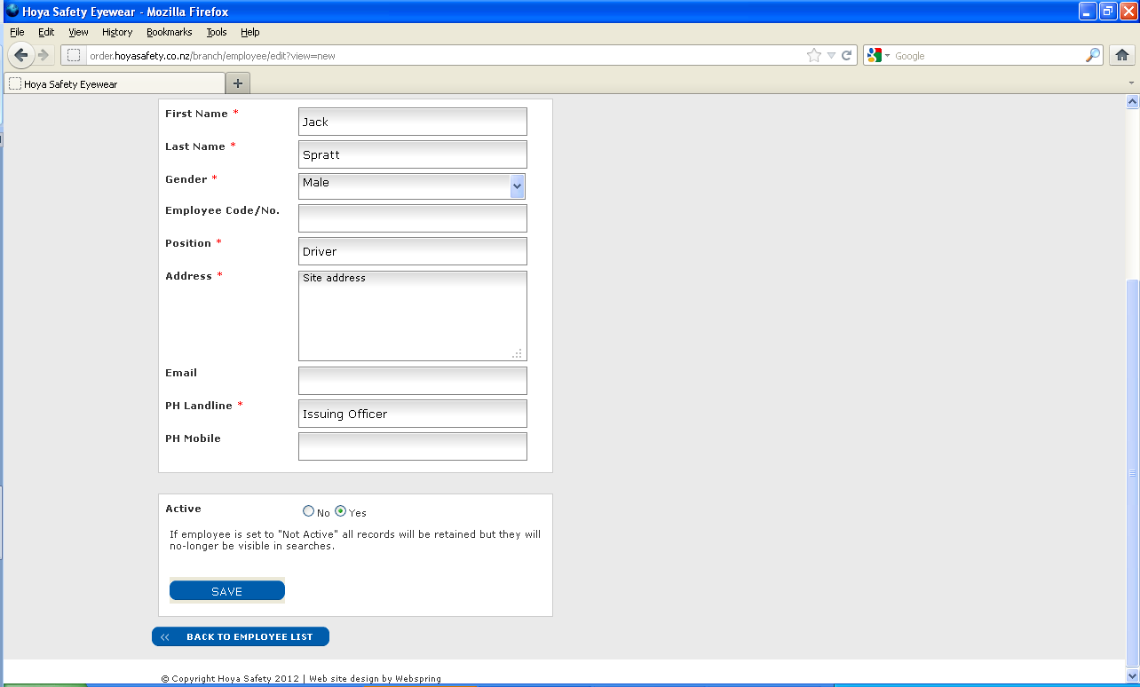
SAVE to proceed to the next page
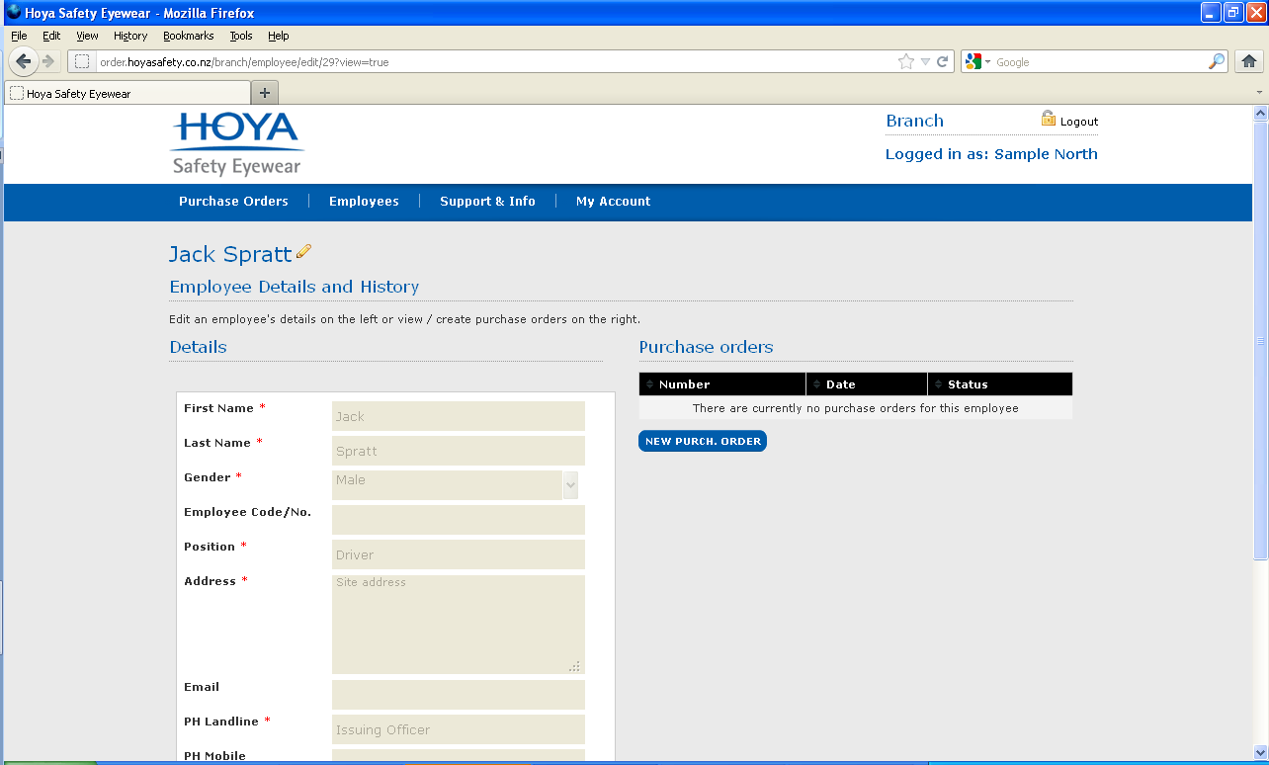
Click here to create a new Purchase Order
Click the Pencil to edit
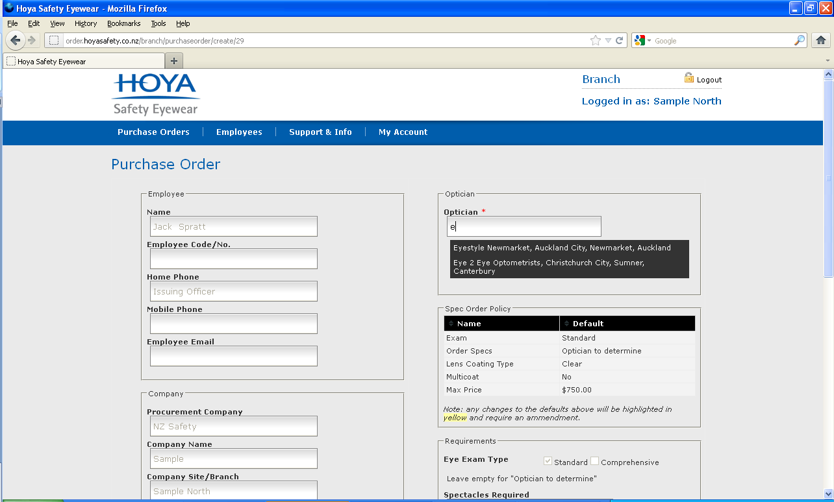
You need to assign an Optometrist to each employee. Type in a letter of the optometrist’s name, suburb or town / city and click on your store of choice.
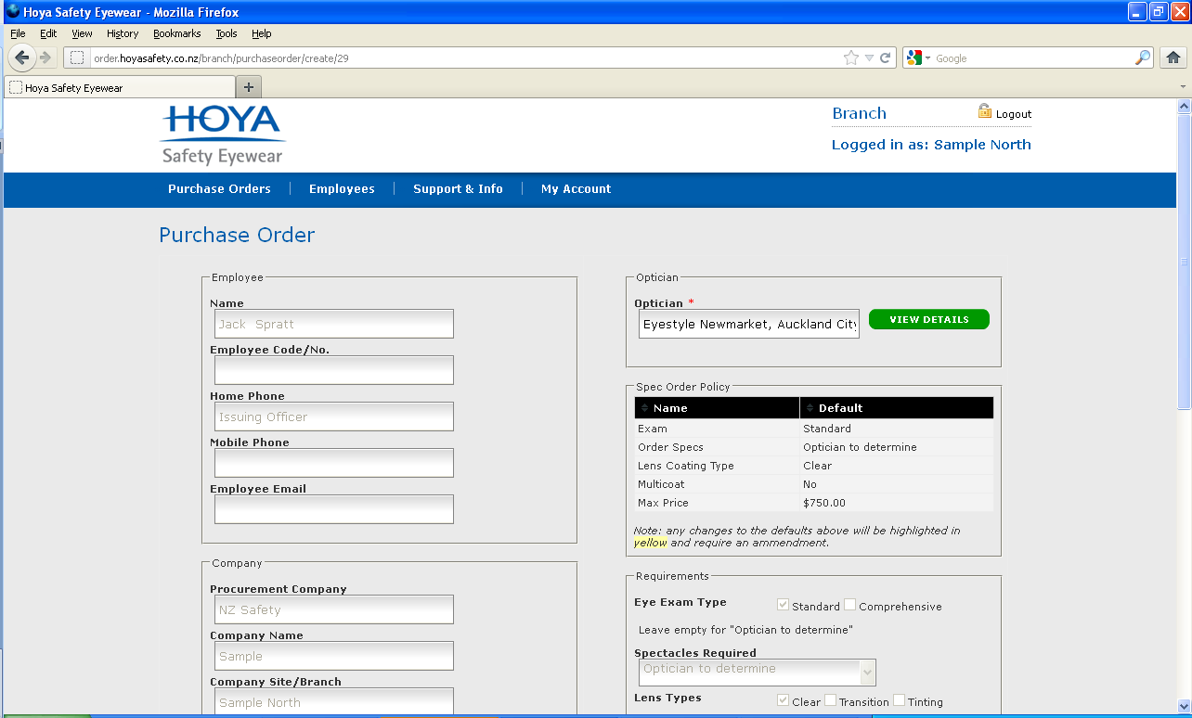
This dialogue box will appear, click here to see information about the Optometrist’s location, hours of trade, car parking etc..

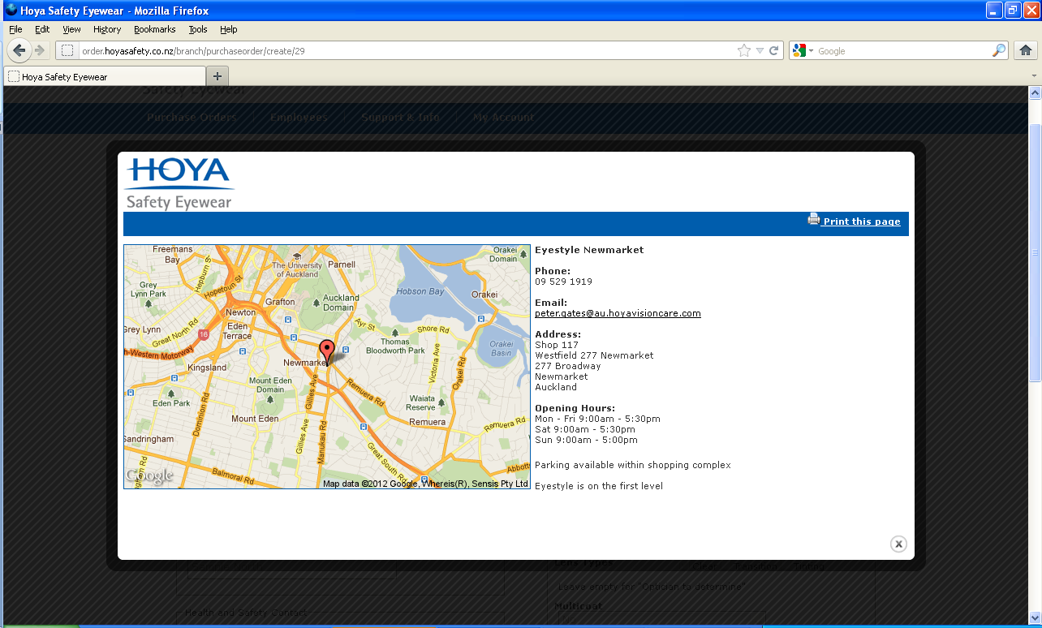
Click in the dark zone to return
... lower part of screen shot.

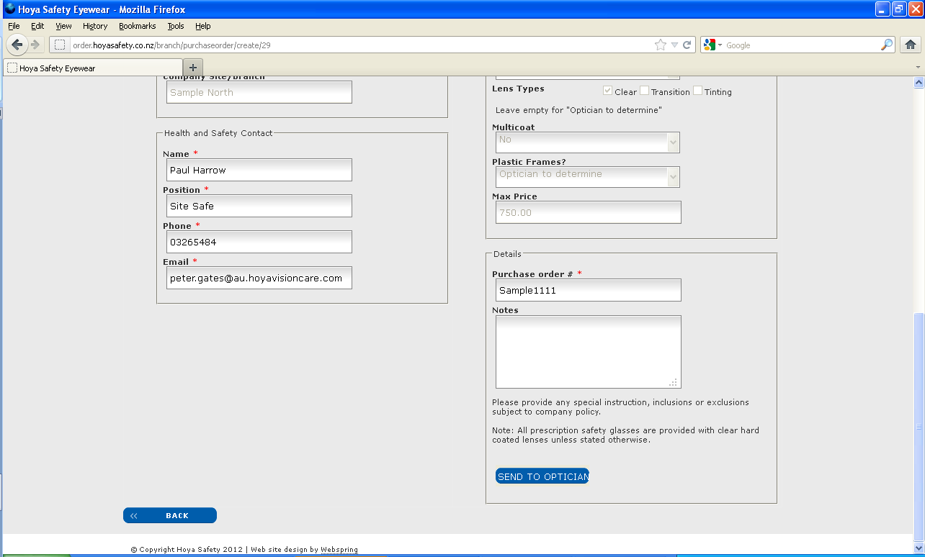
IMPORTANT
Click here to return back to create the next Purchase Order
Click here to send the Purchase Order to the Optician / Optometrists; End of process.
Add your Purchase Order # here
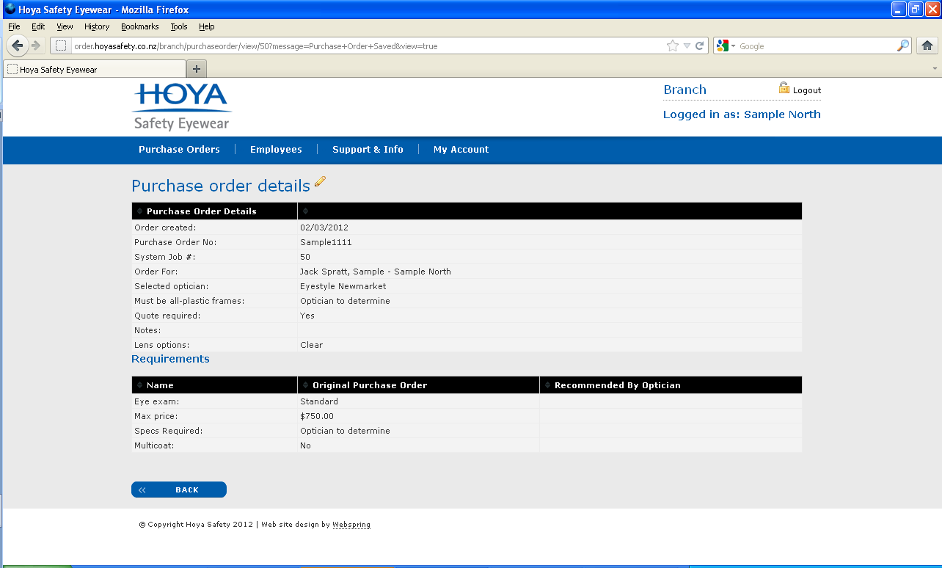
IMPORTANT
Click here to return back to create the next Purchase Order
Summary of the Purchase Order
sent to the Optometrist
If it is Company policy to receive a quote as indicated here, the issuing officer will receive an email from the optometrist with details of teh proposed order, see below.

If it is Company Policy to receive a quote per Purchase Order, the issuing officer will receive an email from the optometrist, click to log in and review.

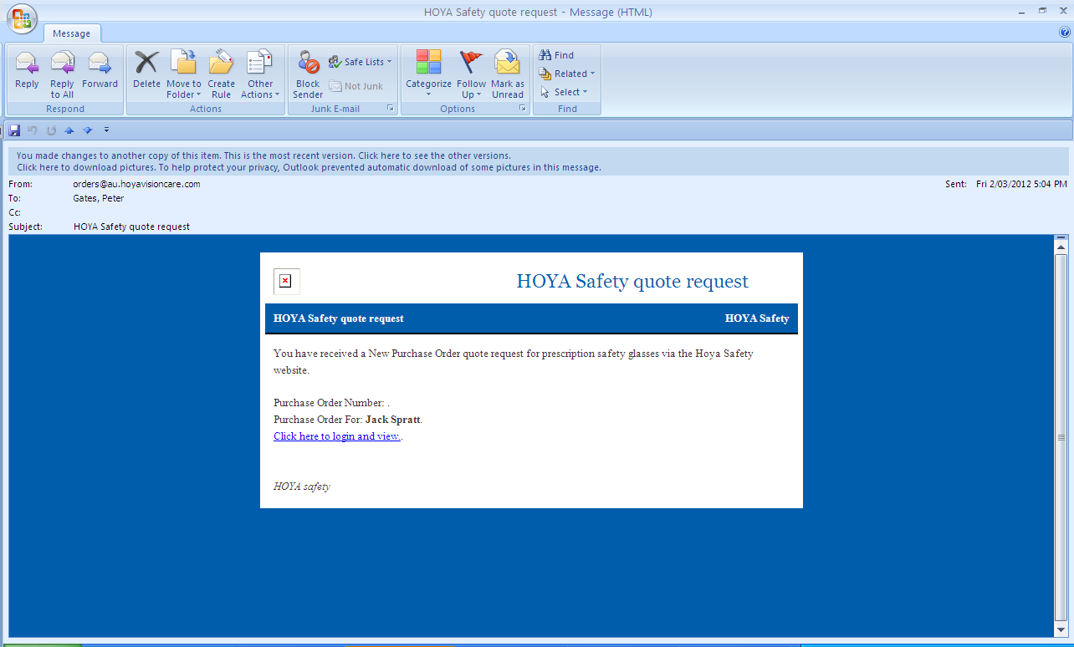
Click here. You will login automatically and see the Request Form
You will receive an email titled HOYA quote request – click to open

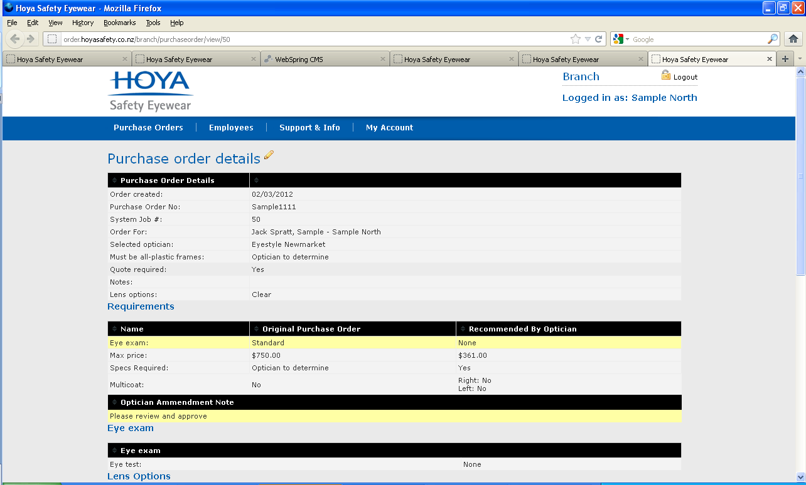
Any changes to the Purchase Order will highlighted in yellow
.... second part of screen shot.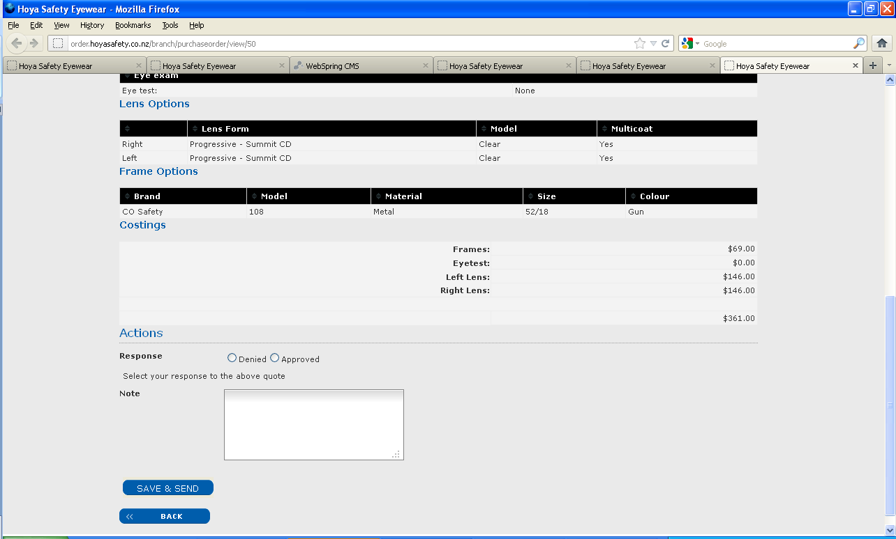
Click here to Save & Send back to the optometrist
Click Denied or Approved
Review & confirm pricing
Add any comments here

